

**JABATAN KEJURUTERAAN ELEKTRIK**

INVESTIGATION REPORT: PROJECT 1

|  |  |
| --- | --- |
| **DIPLOMA** | **: ELECTRICAL ENGINEERING** |
| **ACADEMIC SESSION** | **: SESI2 2021/2022** |
| **TITLE** | **: COAL MINE SAFETY MONITORING AND ALERTING SYSTEM** |
| **NAME** | **: LEE BO CHEN** |
| **REGISTRATION NO.** | **: 03DET20F180** |
| **SUPERVISOR** | **: MOHAMAD RIZAL BIN MOHAMAD TAIB** |
| **COMMENT** | **:** |

TABLE OF CONTENTS

1.1 Introduction 3

1.2 Problem Statement 4

1.3 Project Objectives 5

1.4 Scope of the Project and Constraints 5

1.5 Literature Review 5

1.6 Project Analysis 7

1.6.1 Cost Estimation 7

1.6.2 Project Duration 9

1.6.3 Project Usability 9

1.7 Evaluate Feasibility 9

1.7.1 Technical Resources 9

1.7.2 Financial Resources 10

1.8 Conclusion and Recommendation 11

1.8.1 Conclusion 11

1.8.2 Recommendation 11

1.8.3 Benefit to Organization /Society/Nation/Others 11

REFERENCES 12

# INVESTIGATION REPORT

## Introduction

With the continuous development of technology, manpower has been greatly reduced, but even if some industries do exist now, we cannot ignore the importance of manpower. Some of these industries help us extract natural resources and require a lot of manpower. One such large industry is coal mining. This extracted coal is then supplied to various other industries, where it is combustion to generate electricity or some other uses. In the mining industry, the safety of human life is the primary concern. Failure to comply with safety guidelines can damage high-quality equipment, hinder production, or result in personal injury or death.

India produces 89 minerals by operating 569 coal mines, 67 oil and gas mines, 1770 non-coal mines, and several more small mines, running into over a lakh, all of them translate into the direct employment of about a million people on a daily average basis and overall sector contribution is about 5 percent of India’s gross domestic product (Pudke & Bhagat, 2017). Even with such lucrative profits from the industry, very few precautions have been taken against mining accidents. The workers in the coal mines will face any problem of humidity, heat, harmful gases, collapse, etc. whereas, the worker due to factors like suffocation, high temperature, harmful gases, humidity, and chances of fire and collapse which creates a great threat to their life. Unsuitable conditions in coal mines include poor lighting, inadequate ventilation, and slippery underground areas. In the presence of highly flammable gases such as methane, uncontrolled temperatures can cause a fire or explosion at any time. Many harmful gases such as carbon monoxide and methane will increase in large quantities by accidental mining by workers or also increase with the depth of the coal mine. Excessive exposure to them is harmful and fatal to human health. The walls of some coal mines will be unstable and loose due to heavy mining, thus increasing the risk of the mine collapse. The humidity in coal mines also will increase when the water source is near the coal mine or heavy rain at the mine. High humidity can have a number of adverse effects on the human body. It can contribute to feelings of low energy and lethargy. In addition, high humidity can cause hyperthermia – over-heating as a result of the body’s inability to effectively let out heat (Sarmiento, 2016).

So to reduce these risks, I will develop a coal mine safety monitoring and alerting system, using ESP32 that can help to monitor the physical conditions like humidity, temperature, gas carbon monoxide, and methane in the coal mine. This system also can be alerting the workers in coal mines where accidents are about to happen like leakage of gas toxics or vibration before the collapse. Besides, this system also can count the number of workers in the coal mine. Additionally, the system also uses green technology, powered by the lion battery and charged by the solar panel.

## Problem Statement

According to Howden (2019), the methane (CH4) in the coal mines is a colourless, odourless, highly flammable, and highly explosive toxic gas. Methane is only flammable at levels between 4 and 16 percent. When these levels of methane are in the air, all it takes is an open flame or spark from a machine to cause an explosion. A sufficient amount of methane can cause suffocation in those who inhale it.

According to Howden (2019), Carbon monoxide (CO) in coal mines is colourless, odourless, and tasteless, making it difficult for humans to detect. It is often referred to as the "silent killer". Carbon monoxide is also cumulative, meaning that a person can be exposed for a short period of time without apparent adverse effects, but, with each interaction, the person will become more and more susceptible to its effects.

Infamously, the canary was used as an early warning against any toxic gases in the past. This is because the toxic gases affects small animals more quickly than humans, and when exposed to toxic gases the bird would fall from their perch alerting the miners to move to safety (Howden, 2019).

According to MSHA (2012), research shows that in hot and humid environments, workers have difficulty concentrating and sometimes take dangerous shortcuts. Agility and coordination, the ability to remain alert during long, monotonous tasks, and the ability to make quick decisions are all adversely affected by high temperatures.

According to Howden (2019), Mine collapses are some of the most widely reported mining accidents around the world. For example the 2010 rescue of 33 miners from a collapsed mine in the Atacama region of Chile where the miners ended up trapped 2,300 feet underground for over two months (Howden, 2019). Collapse can be caused by inappropriate mining activities, such as blasting or so-called retreat mining. Collapses also occur due to the low predictability of seismically active earthquakes.

## Project Objectives

* Review on the project regarding coal mine safety monitoring and alerting system.
* Design circuit for coal mine safety monitoring and alerting system.
* Develop coding for coal mine safety monitoring and alerting system.

## Scope of the Project and Constraints

The scope of this project is focused on the coal mine. This project uses an MQ-4 to sense gas methane and use an MQ-7 to sense carbon monoxide. This project also uses a vibration sensor to sense vibration in mine and uses DHT22 to sense humidity and temperature. Besides, this project also uses IR sensors to detect the number of workers in the coal mine. ESP32 is used for the processor core for this project and the OLED display is used to display the parameters sensed by sensors. Besides, this project also have use Blynk to display the parametes on the mobile phone.

The alerting system for this project uses the buzzer module and the buzzer can alert the workers in the coal mine where accidents are about to happen. This project also have use green technology by using the lion batteries as the supply and charged by the solar panel.

The users suitable for this project are coal miners in the coal mines. Project will be completed within 30 days, cost of developing project is RM390.09, and hardware resources are available for one month.

## Literature Review

|  |  |  |  |  |
| --- | --- | --- | --- | --- |
| **NO** | **TITLE/AUTHOR** | **OBJECTIVE** | **METHOD** | **RESULT** |
| 1 | * **Research of Intelligent Gas Detecting System for Coal Mine.** (Hui, 2011) * Chen Hui | A system to detect gas CH4 and automatic warning of danger. | The detector adopts the single-chip AT89S52 as the control core and uses the catalytic combustion gas sensing element MC112 as the gas CH4 detection sensor. | Real-time monitoring of gas concentration, the transmission of dynamic safety operation parameters in coal mines, automatic warning of danger before accidents occur, and useful information for decision-makers to rescue and evacuate personnel or equipment. |
| 2 | * **LabVIEW Based Coal Mine Monitoring and Alert System with Data Acquisition.** (Pudke & Bhagat, 2017) * Ashwini J. Pudke, Sanket N. Bhagat, Dr. S. L. Nalbalwar, Dr. Babasaheb Ambedkar | An embedded system that helps to monitor the physical conditions in the underground coal mine. | The system adopts the microcontroller ATMEGA 2560 as the control core, uses ZigBee module as wireless communication, uses MID04 as the gas CH4 detection sensor, uses MG-811 as the gas CO detection sensor, uses HSM-20G as humidity detection sensor, uses LM-35 as temperature detection sensor, and uses GSM module for sending messages to control room. | The front panel shows the sensor's values for the sensed parameters. It also provides the flexibility of adjusting threshold values as per the mine conditions. When sensor values exceed the predefined threshold values it gives an indication by turning the LED on giving a buzzer alert. At the same time, GSM is also operated for a call or SMS alerts. |
| 3 | * **Design Of Underground Coal Mine Monitoring System.** (Pandit & Rane, 2020) * Vaibhav Pandit, Prof. U. A. Rane | Proposes a mine safety monitoring system based on ARM7 and ZigBee to achieve the safety factors. | The system adopt LPC2148 as the control core, uses MQ-7 as the toxic gases detection sensor, uses temperature sensor as the temperature detection sensor, uses humidity sensor as the humidity detection sensor, uses LCDs as the interface, and ZigBee module as a wireless communication. | The LCDs shows the sensor's values for the sensed parameters. When sensor values exceed the dangerous values it gives an indication by turning the LED on giving a buzzer alert. At the same time, GSM is also operated for a SMS alerts. |
| 4 | * **Safety Monitoring System in Coal Mine Using IoT.** (Sathishkumar, Manoj A, Muniraj, Naveenkumar, 2022) * Sathishkumar, Manoj A, Muniraj, Naveenkumar, Praveen | Proposes a design for coal mines that will reduce the damage caused by a coal mine accident and allow for a more effective rescue operation. | The system adopts Arduino UNO as a processor core, uses the gas sensor as the toxic gases detection sensor, uses the LM35 sensor as a temperature sensor, uses the vibration sensor as a vibration detector, and LCDs as the interface. | The Temperature, vibration, and gas esteem is the sequential monitor. If any questionable conditions happen, a warning is shipped off the mail of the approved individual. |
| 5 | * **Bidirectional Visitor Counter with Automatic Light Control using Arduino.** (Dahal, 2022) * Jasmine Dahal | Bidirectional Visitor Counter with an Automatic Light Control System using Arduino. | The project adopts Arduino UNO as a processor core, uses pair of IR sensors to detect visitors from both directions, uses the OLED display as the interface, and uses the relay module as a switch. | The IR sensors can detect the number of visitors in the room and the OLED display will show the number of visitors in the room. When the room has the visitor the light will switch on by relay. |

## Project Analysis

### 1.6.1 Cost Estimation

This project involves the cost of purchasing components and materials throughout its implementation. Components involving cost are hardware ESP32, OLED display, IR range finder sensor, DHT22, vibration sensor, MQ-4, MQ-7, PVC junction box, buzzer piezo alarm driver module, lithium battery 3.7V, and 100W solar panel kit. All of these components are purchased through online purchase methods to make it easier as well as save on costs.

The overall gross budget estimate for the implementation of this project is RM 295.09 and other expenses are RM 95 as shown in Table 1. The project's cost is also in line with one of the key features of a good project developer that is low cost but has a high-quality project.

**Table 1: List of Components and Materials**

|  |  |  |  |  |
| --- | --- | --- | --- | --- |
| **No.** | **Component and materials** | **The unit price** | **Quantity** | **Total** |
| 1 | ESP32 | RM 20.14 | 1 | RM 20.14 |
| 2 | OLED display | RM 14.90 | 1 | RM 14.90 |
| 3 | IR range finder sensor | RM 2.90 | 2 | RM 5.80 |
| 4 | DHT22 | RM 14.90 | 1 | RM 14.90 |
| 5 | Vibration sensor | RM 2.70 | 1 | RM 2.70 |
| 6 | MQ-4 | RM 5.80 | 1 | RM 5.80 |
| 7 | MQ-7 | RM 5.40 | 1 | RM 5.40 |
| 8 | PVC junction box (6”8”3”) | RM15.20 | 1 | RM15.20 |
| 9 | Buzzer piezo alarm driver module | RM2.90 | 1 | RM2.90 |
| 10 | Lithium battery 3.7V 4500mah | RM3.45 | 3 | RM10.35 |
| 11 | 100W Solar panel kit | RM97.00 | 1 | RM97.00 |
| 12 | Other materials | RM50 | - | RM50 |
|  | **Total :** | | | **RM 295.09** |
|  | **List of other costing** |  |  |  |
| 1 | Transportation |  |  |  |
| 2 | Postage |  |  |  |
| 3 | Craft Work |  |  |  |
| 4 | Internet |  |  |  |
| 5 | Application |  |  |  |
|  | **Total :** | | | **RM95.00** |
|  |  |  | **Overall total** | **RM 390.09** |

### 1.6.2 Project Duration



### 1.6.3 Project Usability

This project can monitoring the parameters like number of worker in the coal mine, humidity, and temperature in the coal mine. It also can alerting the worker in the coal mine when occurs an accident in the coal mine. This project is focus on the coal mine, and the usability of the project is for the coal miner.

## Evaluate Feasibility

### 1.7.1 Technical Resources

### The project used ESP32 DEVKITV1 as an MCU. The ESP32 is dual-core, which means it has 2 processors and also can run 32 bits. MQ-4 and MQ-7 sensors is a gas sensor, thus it can detect the gas in air, but MQ-4 sensor is more sensitive for gas Methane (CH4) and MQ-7 sensor is more sensitive for gas carbon monoxide (CO). DHT22 sensor is a humidity and temperature sensor, but it has more accuracy than DHT11 sensor. Vibration sensor is a piezoelectric accelerometer that sense vibration. IR sensor is a simple sensor, and fast obstacle detection via infrared reflection. Therefore, with ESP32 and some coding, it can be used for count people in and out.

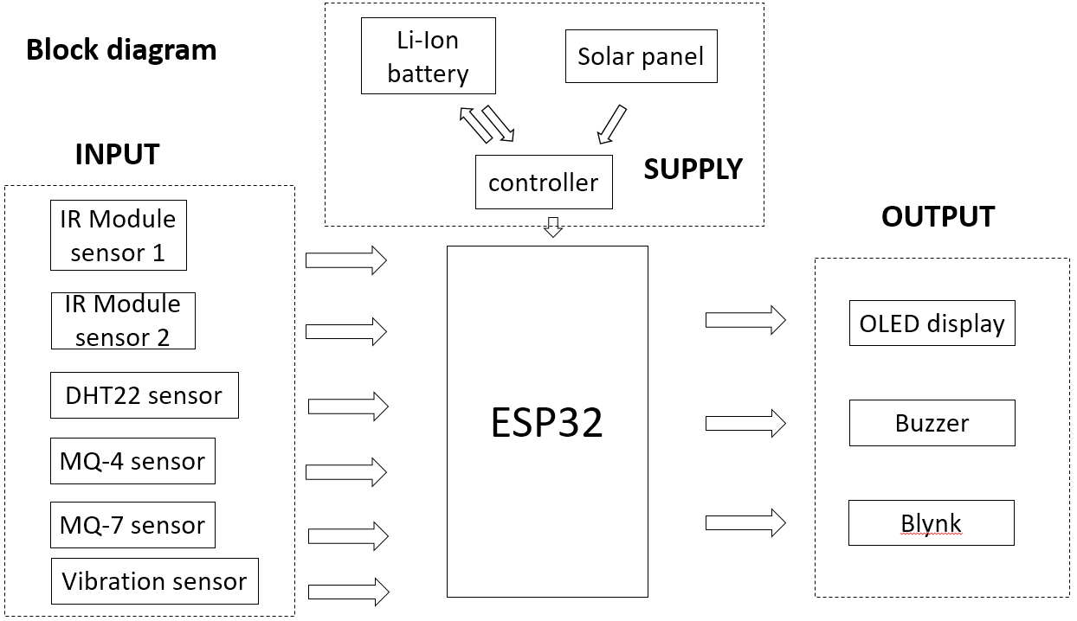

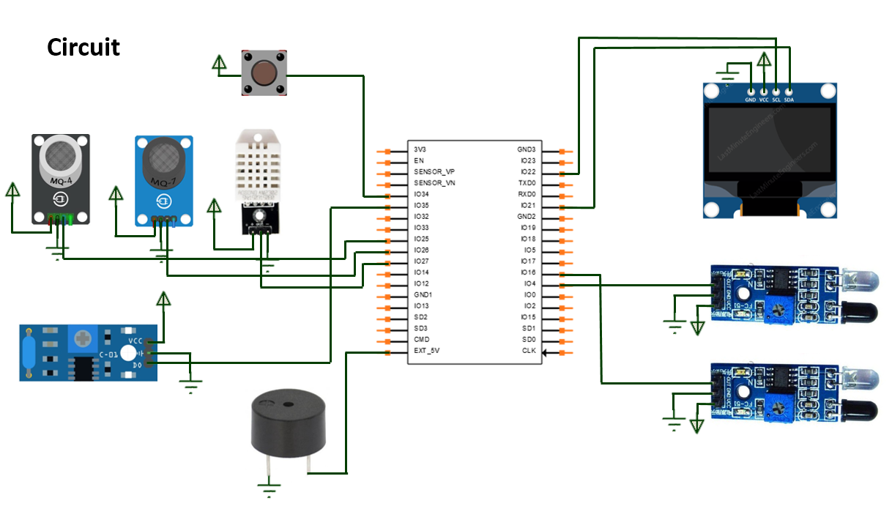

### 1.7.2 Financial Resources

Financial resources for this project are self-financed with some basic components and materials sourced at the project laboratory. The other components and materials will order by using Shopee. Based on the cost projection it is estimated at RM400. The development cost is still feasible with the duration of 4 months with only RM100 per month. It is feasible and achievable based on the investigation.

## Conclusion and Recommendation

### 1.8.1 Conclusion

The coal mine safety monitoring and alerting system is used for monitoring the mine condition and alerting the worker in the coal mine. The system measures the coal mine condition with the help of various sensors such as DHT22, IR sensors, vibration sensor, MQ-4 sensor, and MQ-7 sensor. When the value of the parameter goes above the dangerous level, the system will use the buzzer as an alarm to alert the worker in the coal mine. Besides, the IR sensors will count that there are still workers in the coal mine.

### 1.8.2 Recommendation

* Use wireless technology to the system like ZigBee or GSM.
* Can solve the problem of unsatisfactory Wi-Fi signal in mines

### 1.8.3 Benefit to Organization /Society/Nation/Others

The benefits of this project are capable of monitoring the parameter value in coal mine. It also can alerting the worker in the coal mine when the parameter value in the coal mine is above the dangerous value. The accidents in the coal mine can even lead to more casualties if not detected and alerting early, besides, the project can also count the number of workers in the coal mine to more quickly determine how many worker are still on the coal mine in the event of an accident.

REFERENCES

# A. J. Pudke, S. N. Bhagat and S. L. Nalbalwar, "LabVIEW based coal mine monitoring and alert system with data acquisition," 2017 International Conference on Intelligent Computing and Control Systems (ICICCS), 2017, pp. 1166-1170, doi: 10.1109/ICCONS.2017.8250651.

Sarmiento, S. (2016, August 12). It’s Not Just the Heat, It Really Is the Humidity: Know the Risks. *NBC News*. <https://www.nbcnews.com/health/health-news/it-s-not-just-heat-it-really-humidity-know-risks-n629486>

*The most dangerous gases in mining*. (2019, October 23). Howden. <https://www.howden.com/en-gb/articles/mining/the-most-dangerous-gases-in-mining>

*We need to talk about mining: Death, dangers & prevention*. (2019, December 5). Howden. https://www.howden.com/en-gb/articles/mining/we-need-to-talk-about-mining

*Heat stress | mine safety and health administration (MSHA)*. (2012). MSHA. https://www.msha.gov/heat-stress

Chen hui. Research of Intelligent Gas Detecting System for Coal Mine. IFIP International Federation for Information Processing 2011, China, Volume-4, 268–278.

Pandit, Vaibhav & Rane, Prof. (2013). Design Of Underground Coal Mine Monitoring System. International Journal of Engineering and Technical Research. 2. 82-90.

Sathishkumar, Manoj, Muniraj, Naveenkumar, & Praveen. (2022, February 23). *Safety Monitoring System in coal mine using IOT - iopscience*. Safety Monitoring System in Coal Mine Using IoT. Retrieved April 23, 2022, from https://iopscience.iop.org/article/10.1088/1742-6596/1916/1/012196

Dahal, J. (2022, February 2). Bidirectional visitor counter with light control using Arduino. Retrieved April 23, 2022, from https://how2electronics.com/bidirectional-visitor-counter-with-automatic-light-control-using-arduino/